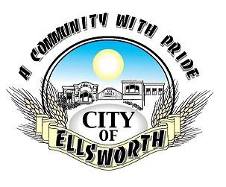

Contractor Checklist for Building Permit Consideration
The following are the things that you will need prior to a Building Permit being issued:
- Pick up and fill out a building permit form to the best of your ability. You can also print one off our website: ellsworthks.net under the department tab in Zoning.
- Sketch the desired improvements on your property with the space provided.
- If your project involves digging or setting posts, be sure to call Kansas One Call by dialing 811 (www.kansasonecall.com).
- If your project involves erecting a fence on your property line, please notify the adjacent property owner and have them sign a letter stating they are comfortable with the proposed fence.
- Please bring your building permit to City Hall or contact the City Inspector if you have questions regarding setbacks or zoning.

After you have done all of these things, the City will respond to your request within three working days. Thank you for our efforts to improve your property and to improve the
City of Ellsworth.

Delvin Bettenbrock
City Building Inspector
121 W. 1st Street/ PO Box 163
Ellsworth, KS 67439
Phone: (785)472-5566
Fax: (785)472-4145
dbettenbrock@ellsworthks.net

